COPY

Note: for consistency, the bottom navigation should say ‘Delivery & Returns’ not ‘Delivery Options & Returns Policy’.

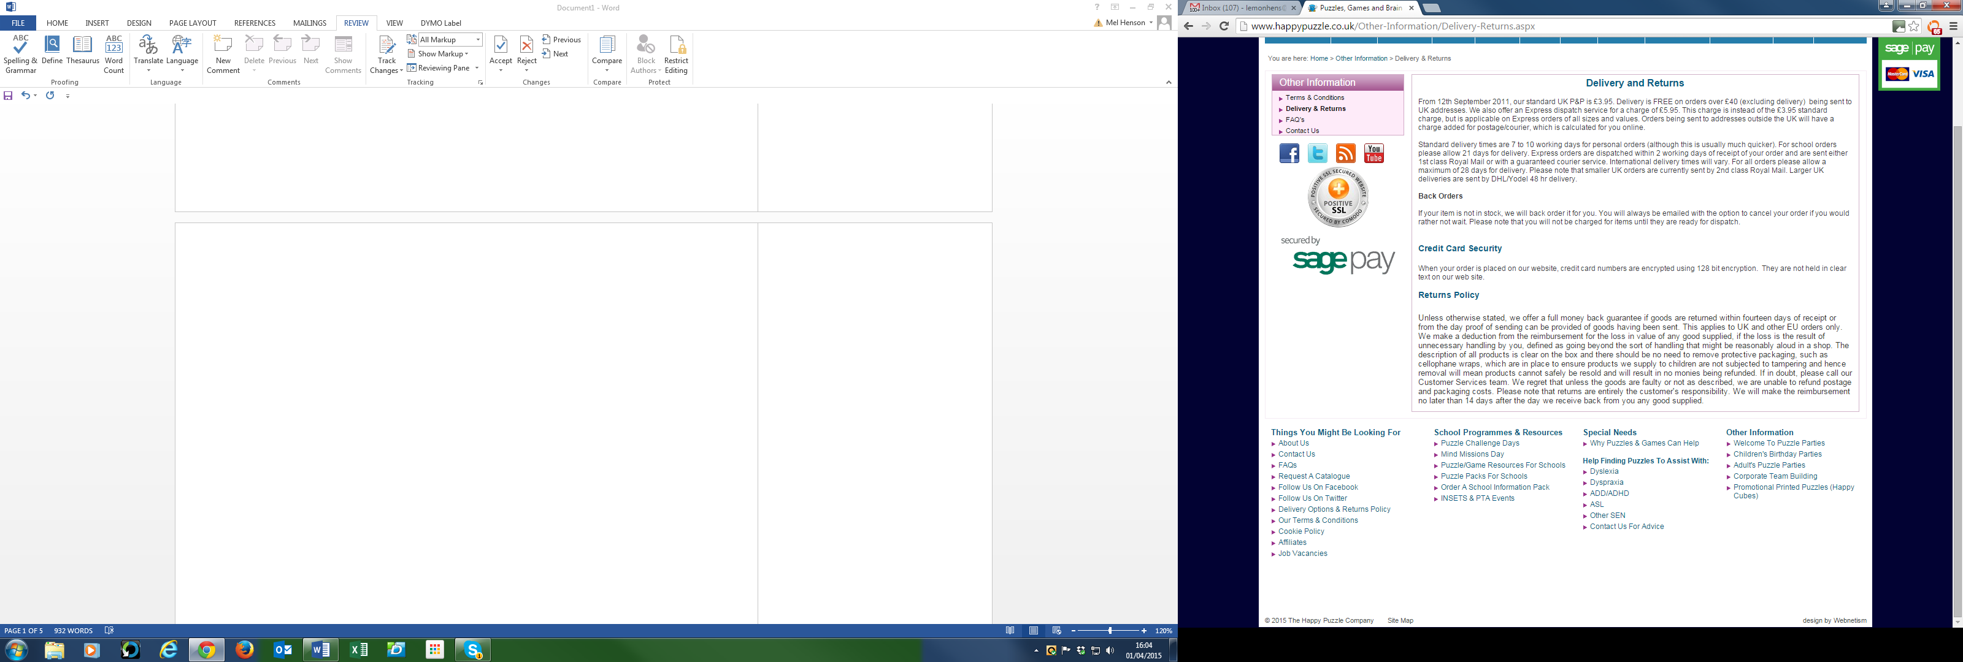

# Delivery and Returns

|  |  |
| --- | --- |
| DELIVERY CHARGES (UK MAINLAND) |  |
| STANDARD DELIVERY - Orders £40 or more | FREE |
| STANDARD DELIVERY - Orders under £40 | £3.95 per parcel |
| EXPRESS DELIVERY – All orders | £5.95 per parcel |

Personal orders usually arrive within 3-5 days, although please allow up to 10 days.

Schools orders usually arrive within 21 days.

Express orders are dispatched within 2 working days.

Orders are despatched by Royal Mail or a guaranteed courier service such as DHL/Yodel.

**Out of stock items**

If your item is not in stock, we will hold your order until it arrives. You will always be emailed with the option to cancel your order if you would rather not wait. Please note that you will not be charged for items until they are ready for dispatch.

**Returns**

You have 14 days to return any unused item for a full refund or exchange. Please obtain proof of posting, as it is your responsibility to return the goods to us in their original, undamaged condition, with cellophane intact and seals unbroken. You are responsible for paying for return delivery, unless the goods are faulty or not as described, in which case we will pay the return costs. Please state whether you would like an exchange or refund, and allow up to 14 days for us to process it for you.

**Please note:** Safety for our children is of paramount importance. For their protection we only sell products in tamper-proof packaging with unbroken seals. We therefore regret that we cannot give a refund if your goods are returned with damaged packaging or with the seals broken. All products have a detailed description on the box, which should be sufficient information to decide if you wish to keep the product.

**FAQ's**

There are lots of questions which our customers ask regularly. To help you, here are some of them, with the answers!  
   
**Q: How will my order be delivered?**  
   
**A:** That depends on the weight of the package.  
   
For lighter packages we normally use the Royal Mail, who will deliver the package either with the rest of your daily post, or when the parcel van comes around. With standard delivery Royal Mail packages, no signature will be required. If you are not at home when the package arrives, the postman should leave you a card with the details of how to collect the parcel from your local delivery office. In our experience however, the card does not always get left for you, especially at peak times. If you are concerned that a smaller order has not arrived, please contact your local Royal Mail delivery office to see if they are holding the parcel for you.  
   
Larger packages will be delivered by a courier, normally DHL / Yodel. A signature will be required for these packages. If you are not in to sign for the package, you will be left a card with contact details so that you can arrange for an alternative delivery time.  
   
**Q: How long will it take for Express Delivery items to arrive?**  
   
**A:**  Express delivery packages are normally sent out the same day, either by Royal Mail first class or a 24 hour courier service. If you need your order by a particular date please let us know and we’ll do our best to make sure it reaches you on time.   
   
**Q: When will I be charged for my goods?**  
   
**A:** We will not charge your Credit or Debit card until your goods are ready for dispatch. If one or more items are placed on back order because they are out of stock, these items will only be charged once they are ready to send to you.  
   
**Q: I have received my order but one or more items say ‘To Follow’. What does this mean?**  
   
**A:**Sometimes, especially at peak periods, there can be a delay in stock reaching us from our supplier. We don’t want to delay your order if at all possible, so we often send the items that are available at the time and send on the other items afterwards. If the delay is significantly longer than expected, we will contact you to let you know.  
   
**Q: My Postcode Map Jigsaw was not included with the rest of my package. When will it arrive?**  
   
**A:** Each Postcode Map Jigsaw is made to order and sent to you separately. As these are bespoke, we have to take payment at the time your order is placed. Your package will be sent directly from the makers, not with the rest of your order.  
   
**Q: I need to contact Customer Services urgently outside of normal opening hours. What should I do?**  
   
**A:**Our Customer Service telephone lines are open from 9am to 5.30pm (Monday to Thursday) and from 8am to 2.30pm (Friday). If you need to contact us outside these times it’s best to send an email to info@happypuzzle.co.uk  
Emails are monitored at all times apart from 2.30pm on Friday until 9am on Sunday.

**Q: Why can I not place my order online?**  
   
**A:** Very occasionally, all websites experience technical problems. In almost every case, a difficulty that you are having will be rectified automatically with a few minutes. Our website is monitored around the clock, but if you are having a problem, please call us on 020 8953 4484.

Q: Do you store my personal details securely?

A: Our website uses advanced security measures to protect your personal details. Your credit card numbers are encrypted, and not held in clear text on our website.